Fig. S1 Read length and quality.
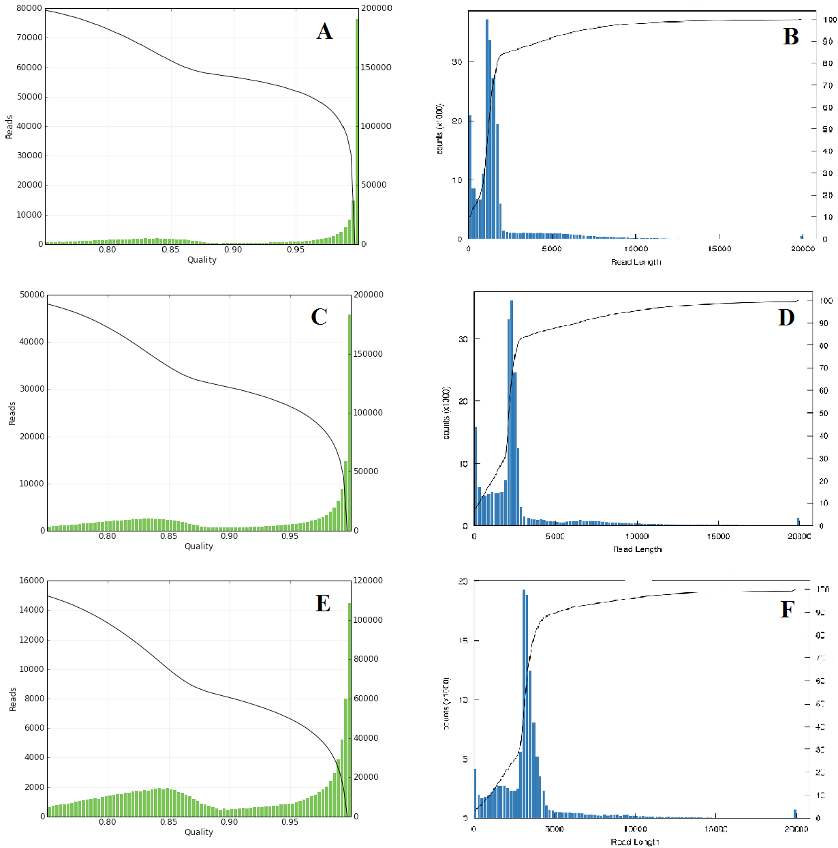

(A) Distribution of read quality in the 1-2 kb library. (B) Distribution of read length in the 1-2 kb library. (C) Distribution of read quality in the 2-3 kb library. (D) Distribution of read length in the 2-3 kb library. (E) Distribution of read quality in the 3-6 kb library.(F) Distribution of read length in the 3-6 kb library.

